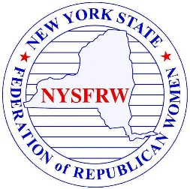
New York State Federation of Republican Women Scholarship

This scholarship was established by the New York State Federation of Republican Women in 2000 in honor of First Lady Nancy Reagan. The annual scholarship of $1000 is given to provide financial assistance and support to a New York State high school senior woman.

New York State Federation of Republican Women Application Checklist

A complete application must include the following:
  - Official application form, all sections fully completed.
  - Three letters of recommendation, including telephone numbers/emails of authors for follow-up. One letter must be from a teacher or guidance counselor.
  - An official copy of the applicant’s most recent high school transcript.
  - A written essay that includes the following:
    - Essay will be 500 words or less, 12 point, and double spaced.
      - How will this scholarship help you?
      - What are your academic and/or career goals?
      - How have you contributed to your community, or a political candidate, or elected official?
      - Tell us about a time you had a belief or idea change?

ONLY COMPLETED APPLICATIONS WILL BE CONSIDERED
Instructions to applicant:
Applications must be submitted electronically to Karen Smith at Camie62113@icloud.com by March 1, 2022.

APPLICATION FOR THE NEW YORK STATE FEDERATION
OF REPUBLICAN WOMEN SCHOLARSHIP

Name:
Address:
City: State: New York Zip:

Are you a U.S. Citizen?
Name of High School:
Guidance Counselor at High School/Phone Number:
Address:
City: State: New York Zip:
How did you learn about this scholarship?
Elected official:
Political Candidate:
New York State Federation Member:
Website:
Other:

High School Activities and Achievements Including Civic and Political Activities and Interests:

